Riflemaker
For immediate release:

Graham Fink

Ballads of Shanghai

1 – 14 FEBRUARY, 2016

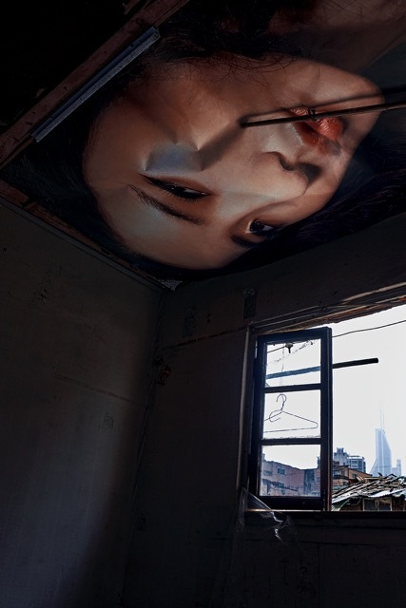

Girl on Roof © Graham Fink

The rapidly changing landscape of urban China is the subject of artist Graham Fink’s solo photographic exhibition, opening at Riflemaker gallery in London on 1 February. Over the course of five years, the artist has documented various demolition sites in and around Shanghai - the largest city by population in the world. The photographic series communicates the enormity of the transition that is taking place there as the country moves increasingly towards a large-scale urbanization and more workers relocate for employment in the manufacturing industries. Not only are new cities emerging but immense urban renewal efforts are underway.

These demolished areas sites are ‘exchange sites’, where the past is being obliterated and exchanged for the future, where a not-so-distant communism gives way to new ideas and structures - super skyscrapers, office buildings and new domestic ways of living. As a result, these sites are in constant flux - the entire areas are flattened to make way for new for new beginnings.

The matte and gloss treatment in the series gives each image a painterly quality - shaping the human aspects, stories and ‘ballads’ that pervade these ‘exchange sites’ - wallpaper clinging to a wall, a child’s drawing on a remnant of what was formerly a bedroom a once favourite chair, now left for economy and industry to reclaim.

ENDS

For further information visit: www.grahamfink.com

Facebook: http://www.facebook.com/grahamfinkart/?fref=ts

Instagram: www.instagram.com/graham_fink/

Contact information:
For press images and information:
Alice Broughton Communications: 07816-7735-44, alicerbroughton85@gmail.com
Tot Taylor, Riflemaker: 07794-629-188, tot@riflemaker.org

Visitor information:
Riflemaker, 79 Beak Street, London W1, 020 7439 0000, www.riflemaker.org
Riflemaker is co-directed by Virginia Damtsa & Tot Taylor
Opening hours: Monday - Friday 10am - 6pm
Saturday 11am - 6pm
Twitter: @Riflemaker_Soho

Instagram: http://www.instagram.com/ riflemaker_soho/

Editor’s notes:

GRAHAM FINK is a multimedia artist. His photography has been used in many advertising campaigns including Sony PlayStation’s Blood and Mental Wealth poster campaigns. He has also directed a short film ( Z ) for the millennium, commissioned by David Puttnam, which was shortlisted at BAFTA.

In 2001, he created thefinktank, a conceptual production company and ideas forum. In 2005, he was awarded a Honorary Doctorate from Bucks New University.

In 2014, he had his first one-man exhibition at London's Riflemaker gallery called NOMADS. In 2015, he had his second exhibition in London entitled Drawing with my eyes. For this he drew directly onto a screen using only his eyes via a Tobii eye tracker and software he developed with Tobii.
Fink is also the Chief Creative Officer at the advertising agency Ogilvy & Mather China.

Before taking up that appointment in April 2011, he was Executive Creative Director at M&C Saatchi in London. In 1995, he began directing television commercials and music videos at the Paul Weiland film company. Previously, he was Deputy Creative Director at the Gold Greenlees Trott, Group Head at Saatchi & Saatchi and WCRS. Before that he was an Art Director at CDP.
He became the youngest ever President of D&AD (Design and Art Directors Association) in 1996. He was subsequently voted into D&AD's The Art Direction Book, representing the top 28 Art Directors of all time.

He is one of the world's most awarded creatives. having won awards at Cannes, D&AD, One Show, BAFTA, Clio's, LIAA, BTAA, Campaign's UK Big Awards, Creative Circle, Mobius, Eurobest, EPICA, New York Festival, China 4A's, Longxi and SPIKES. In 2011, he won the UK Creative Circle President's Award. And in 2012, he won Ogilvy Asia's first ever Cannes Grand Prix.

RIFLEMAKER was opened in 2004 by collectors Virginia Damtsa and Tot Taylor. The gallery is housed in one of London's oldest public buildings, a Georgian riflemaker's workshop dating from 1712. Riflemaker exhibits the work of the very best emerging international artists in this unique historic space.

